UNIVERSITY OF LONDON
GOLDSMITHS COLLEGE

B.Sc. Examination 2016

COMPUTING AND INFORMATION SYSTEMS

IS53002A Neural Networks

Duration: 2 hours 15 minutes

Date and time:

This paper is in two parts: part A and part B. You should answer ALL
questions from part A and TWO questions from part B. Part A carries
40 marks, and each question from part B carries 30 marks. The marks
for each part of a question are indicated at the end of the part in
[.] brackets.

Electronic calculators must not be programmed prior to the examination. Calculators which display graphics, text or algebraic equations are not allowed.

THIS PAPER MUST NOT BE REMOVED FROM THE EXAMINATION ROOM

Part A
Question 1.

a) Explain briefly what is the difference between feedforward and recurrent neural
networks with respect to their connectivity pattern. [4]

b) Give the training rule for single-layer thresholded Perceptron networks. Explain
each term in the training formula. [5]

c) What are the main five differences between Multilayer Perceptron (MLP) neural
networks and Radial-basis function (RBF) networks? [5]

d) A Multilayer Perceptron (MLP) neural network with 3 hidden nodes and 1 output
node is given. All nodes in this network use sigmoidal activations. There are
2 inputs passed to the network, and 8 weights as illustrated in the figure below.
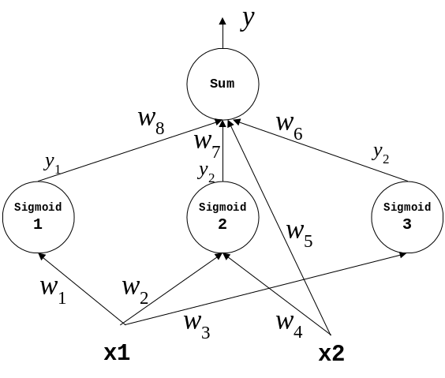

Write down the equations for training the input-to-hidden node weights
w₁, w₂, w₃ and w₄ according to the backpropagation training algorithm. [14]

e) Which are the two main groups of neural network committees and the methods
each of them? [6]

f) Define the formula for the energy of Hopfield neural networks and explain how
it changes during network training. [6]

Part B
Question 2.

a) Apply the training examples given below to a single-layer sigmoidal Perceptron
neural network with three inputs and no threshold (i.e. without bias). This network
computes the function: y = Sigmoid( w₁ x₁ + w₂ x₂ + w₃ x₃ ). Consider each training
example in the given order assuming learning rate η=0.2.
x₁ | x₂ | x₃ | y
0.5 | 0.1 | –0.25 | 1
–0.45 | 0.4 | 0.1 | 0
0.55 | 0.15 | –0.2 | 1

Demonstrate one cycle of training using the batch (off-line) gradient descent
learning rule. Begin with initial weights: ( w₁, w₂, w₃ )=( 0.1, –0.2, 0.3 ). [21]

b) Construct a single-layer Perceptron network with 3 binary inputs and a bias term
with input x₀ =0,. The network that produces output y =1 only when most of the
inputs are one, that is the inputs with values x_{i} =1 are more than these with
values x_{i} =0 (where: 1<=i<=3). Assume the following thresholding function:
f(x)=1 if s>=2 and 0 otherwise.

i) Show the analytical formula for this majority function using weights w_{i}
and inputs x_{i}. [3]

ii) Give proper integer weights without training the network (using the integers:
0, 1, 2), and draw the architecture of the network. [6]

IS53002A 2016 TURN OVER

Part B
Question 3.

a) i) Explain briefly how self-organized learning is performed by Kohonen neural
networks. [5]

ii) Give the name of each layer in the structure of self-organizing Kohonen
networks and describe briefly what it performs. [6]

iii) Write the formula for computing the distance between the weight vector and
the training input example used for unsupervised learning with Kohonen
neural networks. [5]

b) Consider a self-organizing Kohonen network with two neurons and three inputs
feeding each neuron. The initial weight vectors are: w₁ = ( –0.2, 0.1, 0.3 ), and
w₂ = ( 0.2, 0.3, –0.2 ). Assume the following input vector: x = ( 0.2, –0.1, 0.1 ).

i) Calculate the outputs from the two neurons in this network. [4]

ii) Explain how the winning neuron is identified, and determine the index of
the winning neuron. [4]

iii) Train the weights of the winning neuron using the training rule for
Kohonen networks using learning rate η=0.15. [6]

IS53002A 2016 TURN OVER

Part B
Question 4.

a) Explain briefly the connectivity pattern in the architecture of Hopfield neural
networks and relate it to the connectivity of Multilayer Perceptrons. [4]

b) Describe the operations performed in the storage phase of the Hopfield
neural networks. [5]

c) Let a simple Hopfield neural network with 3 neurons and 3 inputs: x₁, x₂, and x₃
be given. The initial weights are given by the following matrix:

0 –0.2 0.4
W = –0.2 0 0.3
0.4 0.3 0
i) Give the formula for computing the neuron output in Hopfield networks. [5]
ii) Calculate the outputs of the neurons in the given Hopfield network for the
state: [1,1,1], and explain why this is a stable state for this network. [8]

iii) Show that the updated network is unstable for the second neuron N₂ given
input vector [1,1,0], and retrain it. [8]

IS53002A 2016 END OF EXAMINATION

